Install Node.js on Windows
Installation Steps
- Download the Windows installer from the Nodes.js® web site.
- Choose the LTS version that’s shown on the left. 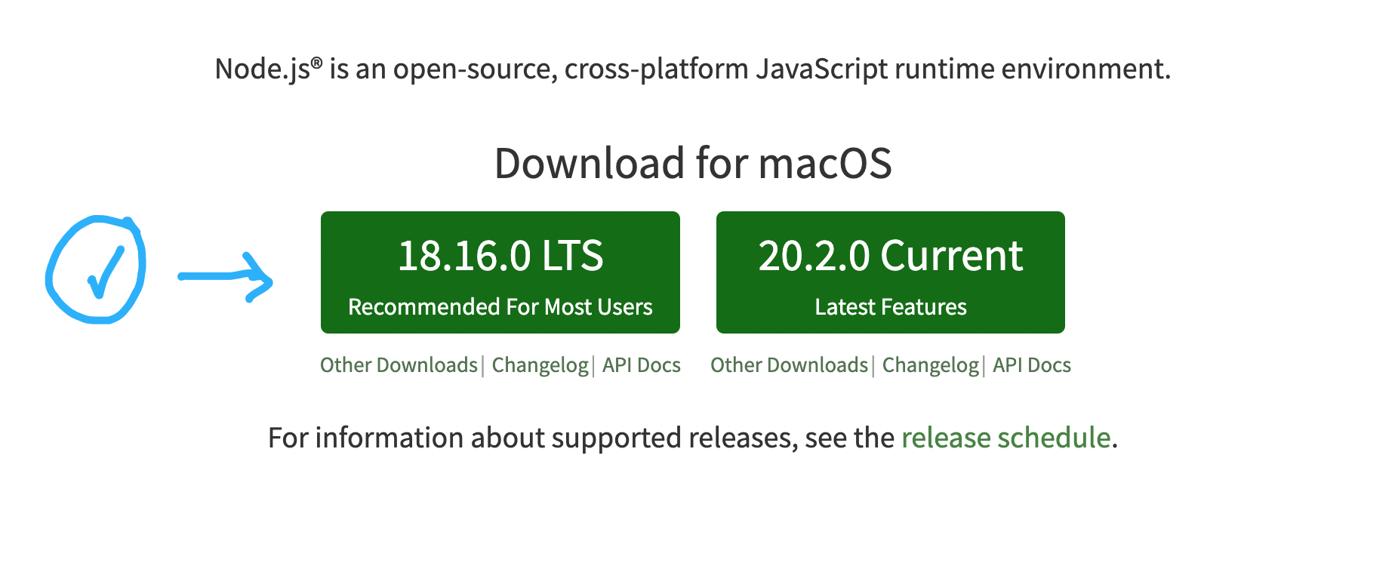
- Run the installer (the .msi file you downloaded in the previous step.)
- Follow the prompts in the installer (Accept the license agreement, click the NEXT button a bunch of times and accept the default installation settings).
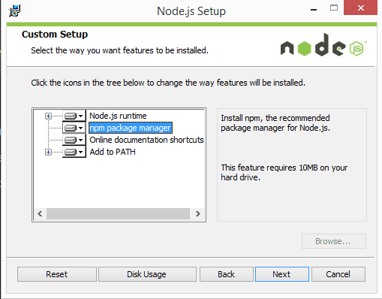

5. Restart your computer. You won’t be able to run Node.js® until you restart your computer.
6. Confirm that Node has been installed successfully on your computer by opening a Hyper terminal and typing in the commands node --version
You should see the version of node you just installed.

